PRACTICAL 2
Aim: Create a Dataset from an Excel file. Apply conditional filtering to extract records where a numerical variable exceeds a given threshold and sort the data descending order.
install.packages("readxl")
install.packages("dplyr")

library(readxl)
library(dplyr)

#Importing Excel File
data <- read_excel("C:\\Users\\Student\\Downloads\\BMW sales data (2010-2024).xlsx")

#Structure of the dataset
str(data)
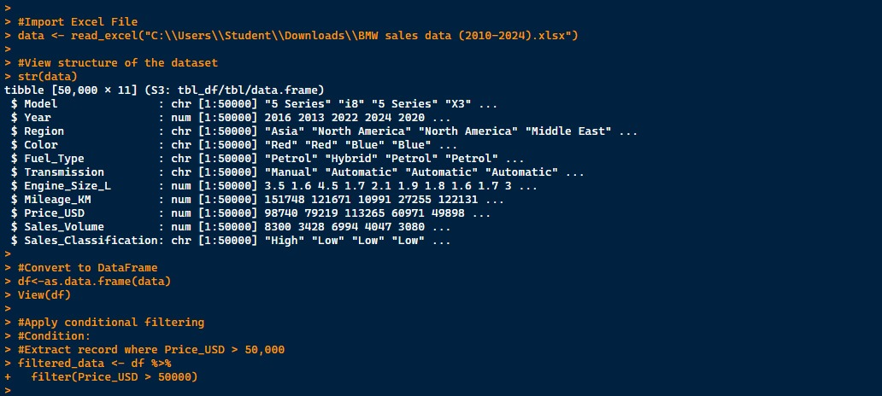

#Converting to DataFrame
df<-as.data.frame(data)
View(df)

#Applying conditional filtering (Price_USD > 50,000)
filtered_data <- df %>%
filter(Price_USD > 50000)

#Sort Filtered data in descending order
sorted_data <- filtered_data %>%
arrange(desc(Price_USD))

#View the result
head(sorted_data)
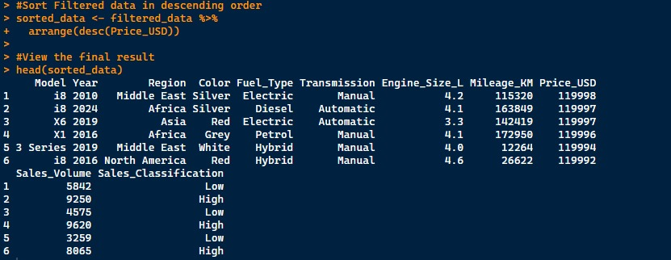

PRACTICAL 3
Aim: Create a Dataset from an Excel file. Apply conditional filtering to extract records where a numerical variable exceeds a given threshold and sort the data descending order.
# Creating employee salary dataset
emp <- data.frame(
EmployeeID = c(101, 102, 103, 104, 105),
Name = c("Aaditya", "Parth", "Padmaj", "Anushka", "Amrita"),
Department = c("Data Scientist",
"Computer Architecture",
"Computer Networks",
"Data Architect",
"UI Designer"),
BasicSalary = c(60000, 55000, 55000, 65000, 50000),
HRA = c(5500, 4500, 3500, 2200, 4200),
Bonus = c(7000, 5000, 3000, 4500, 3500),
Age = c(19, 19, 18, 19, 19)
)

# View Dataset
emp

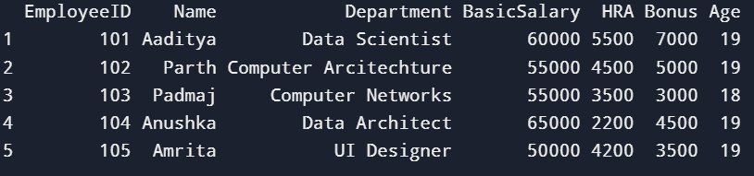

# Select salary-related columns
emp_selected <- emp[, c("EmployeeID", "Department",
"BasicSalary", "HRA", "Bonus")]

# View selected data
emp_selected

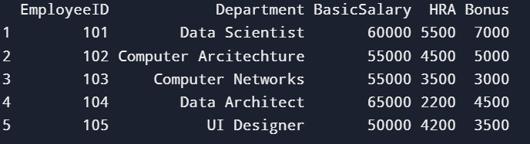

# Calculate Total Salary
emp_selected$TotalSalary <-
emp_selected$BasicSalary +
emp_selected$HRA +
emp_selected$Bonus

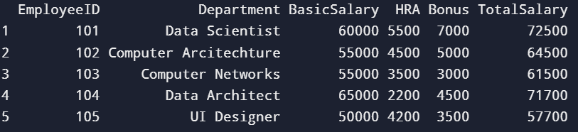

# Calculate Annual Salary
emp_selected$AnnualSalary <- emp_selected$TotalSalary * 12

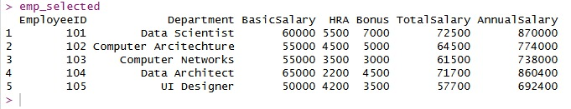

# View structure
str(emp_selected)

# View final dataset
emp_selected

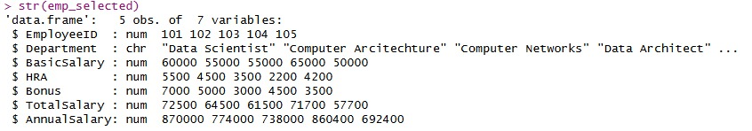
PRACTICAL 4
Aim: Identify and remove duplicates observation from a dataset. Display the numbers of records before and removing duplicates.
#Import Dataset
data<-read.csv("C:\\Users\\Student\\Downloads\\Iris.csv")
View(data)

# View structure
str(data)

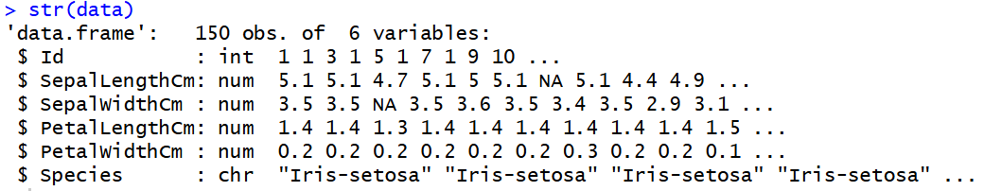

#Count Records Before Removing Duplicates
# Number of records before removing duplicates
before_count <- nrow(data)
before_count

# Identify Duplicate Observations
# Identify duplicate rows
duplicate_rows <- duplicated(data)

# Count duplicate rows
sum(duplicate_rows)

# Remove Duplicate Observations
# Remove duplicate rows
data_unique <- data[!duplicated(data), ]

# Number of records after removing duplicates
after_count <- nrow(data_unique)
after_count

# Display record count comparison
record_summary <- data.frame(
Before_Removing_Duplicates = before_count,
After_Removing_Duplicates = after_count
)

record_summary

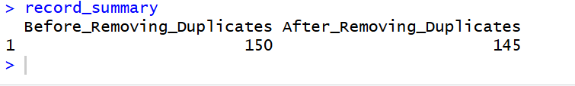
PRACTICAL 5
Aim: Reshape a wide-format dataset into long format and then convert it back to wide format using appropriate R functions.
install.packages("tidyr")
library(tidyr)

student_marks<-data.frame(
Student_ID=c(101,102,103),
Math=c(78,85,90),
Science=c(82,88,91),
English=c(75,80,89)
)

student_marks

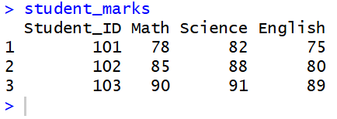

long_data<-pivot_longer(
student_marks,
cols=c(Math, Science, English),
names_to="Subject",
values_to="Marks"
)

long_data

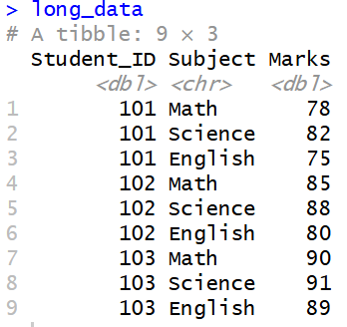
wide_data <- pivot_wider(
long_data,
names_from = Subject,
values_from = Marks
)

wide_data

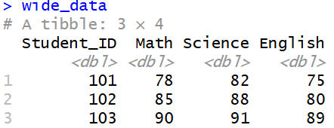
PRACTICAL 6
Aim: Generate descriptive statistics and frequency tables for categorical and numerical variables. Interpret the result briefly in comments.
data <- data.frame(
employee_id = 1:10,
age = c(20,50,20,25,30,26,40,50,60,70),
salary = c(20000,30000,50000,80000,40000,40000,70000,60000,50000,30000),
department = c("IT","IT","Java","Python","Computer Network","HR","Manager","UI","Developer","Operator"),
gender = c("Male","Female","Male","Female","Male","Female","Male","Female","Male","Female"))

# View data
data
str(data)

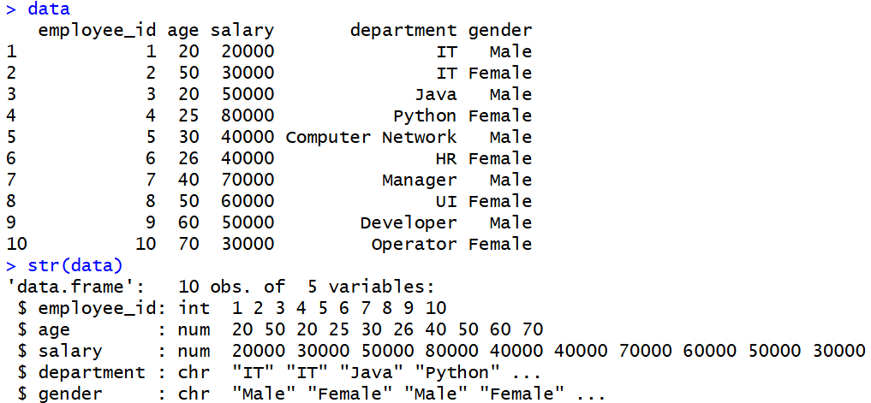

# Summary statistics
summary(data$age)
summary(data$salary)

mean(data$age)
median(data$age)
sd(data$age)

mean(data$salary)
median(data$salary)
sd(data$salary)

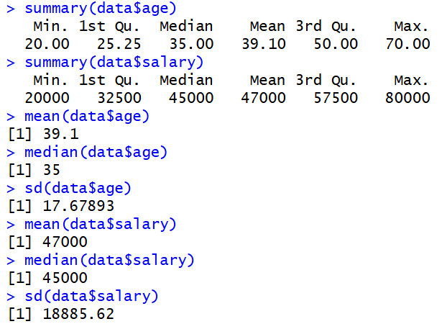

# Frequency tables
table(data$department)
table(data$gender)

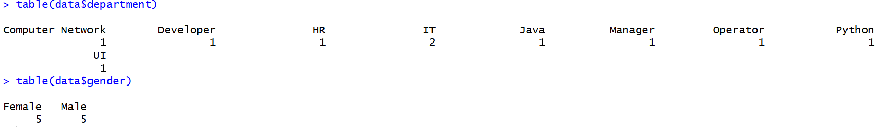

# Percentage tables
prop.table(table(data$department)) * 100
prop.table(table(data$gender)) * 100

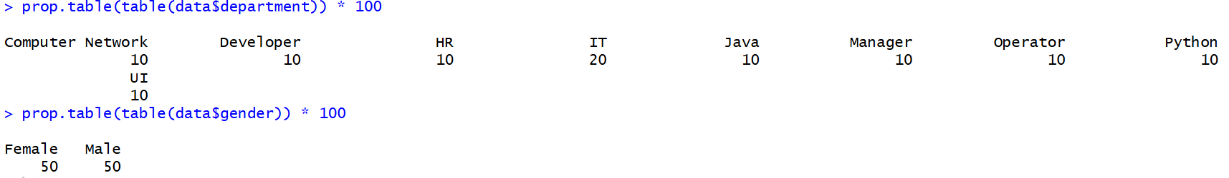

# Psych package
install.packages("psych") # run once
library(psych)

describe(data[, c("age", "salary")])

PRACTICAL 7
Aim: Perform a one-sample t-test and an independent two-sample t-test on a suitable dataset. State Null and alternative hypotheses and interpret the result.
Practical 7
#Custom dataset
#Performing this test for the Single sample.
scores <- c(65,70,72,68,75,78,74,69,71,73)
t.test(scores, mu = 70)

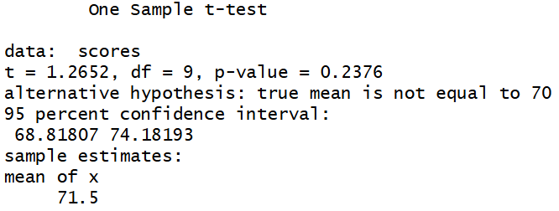

#For Double dataset
group_A <- c(70,72,68,75,74,71,69)
group_B <- c(65,67,70,66,68,64,69)
t.test(group_A,group_B,var.equal = TRUE)

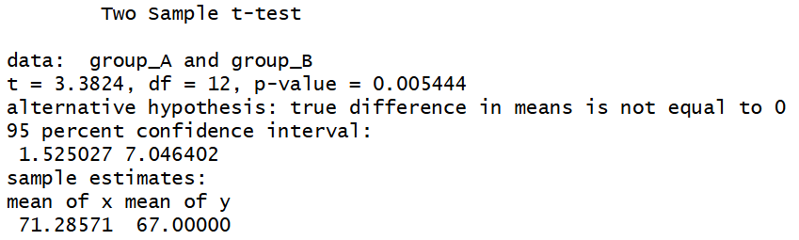

Practical 7' (Optional)
#For Random: Single Dataset
set.seed(123)

scores <- rnorm(1000, mean= 72, sd = 10)

t_test_one <- t.test(scores, mu = 70)
t_test_one

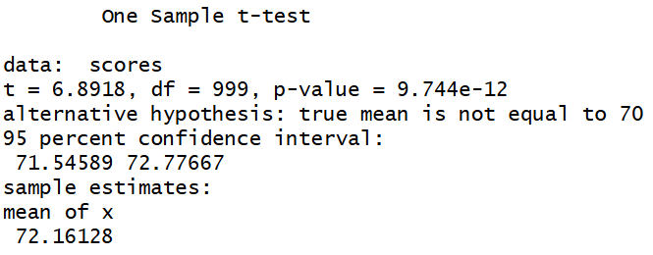

#For Random: Double Dataset
set.seed(456)

male_scores <- rnorm(1000,mean = 68, sd = 9)
female_scores<-rnorm(1000, mean=72, sd=8)

t_test_two<-t.test(male_scores, female_scores)

t_test_two
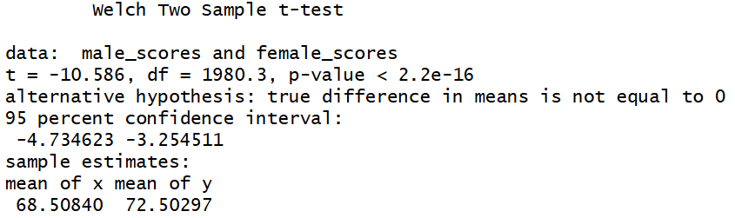

PRACTICAL 8
Aim: Conduct a Chi-Square test of independence using a contingency table. Display expected frequencies and interpret the test result.
#Contigency Table
job_table<-matrix(
c(220, 180, 200,
240, 260, 300),
nrow=2,
byrow=TRUE
)

#Adding Row and Column Names
rownames(job_table)<-c("Male", "Female")
colnames(job_table)<-c("IT", "Management", "Government")

job_table

chi_test<-chisq.test(job_table)
chi_test
chi_test$expected

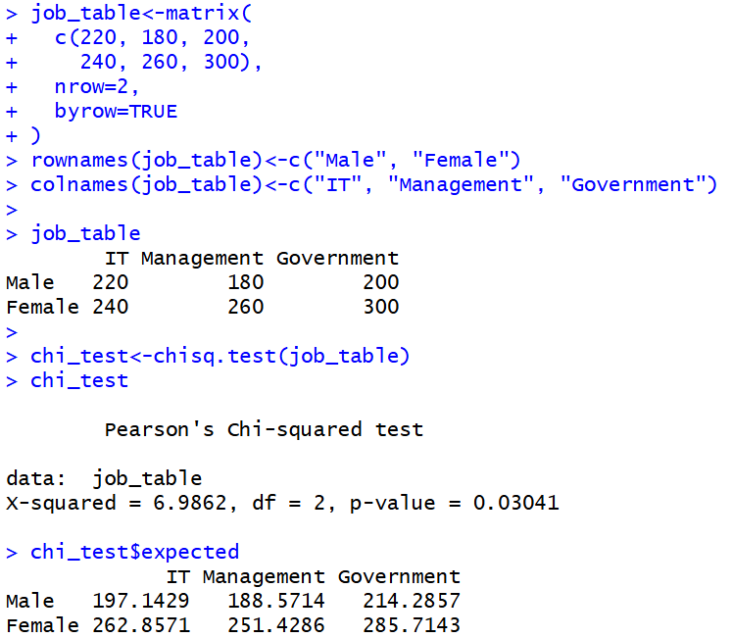
PRACTICAL 9
Aim: Create a visualization including histogram, box plot, and scatter plot using ggplot2. Customize labels and titles appropriately.
install.packages("ggplot2")
library(ggplot2)

Create sample dataset
data <- data.frame(
Age = c(22,25,30,35,28,40,45,50,32,27,29,34,38,42,48),
Salary = c(25000,28000,35000,40000,30000,45000,50000,55000,37000,29000,31000,38000,42000,47000,52000)
)
View(data)

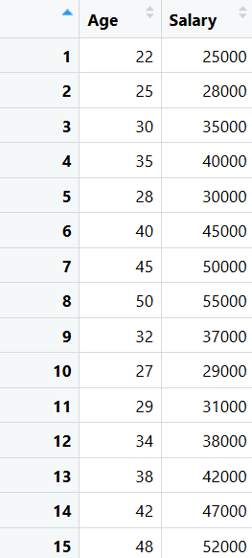

1.Histogram(Distribution of Age)
ggplot(data, aes(x=Age)) +
geom_histogram(binwidth = 5,fill ="skyblue",color = "black")+
labs(
title="Histogram of Age Distribution",
x = "Age (Years)",
y = "Frequency"
)+
theme_minimal()

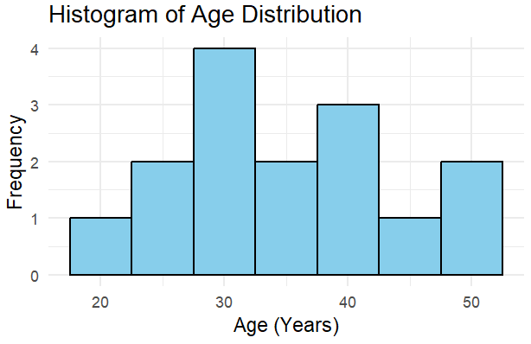

2.Box Plot (Salary Distribution)
ggplot(data, aes(y=Salary))+
geom_boxplot(fill = "lightgreen")+
labs(
title="Box Plot of Salary",
y="salary(INR)"
)+
theme_minimal()

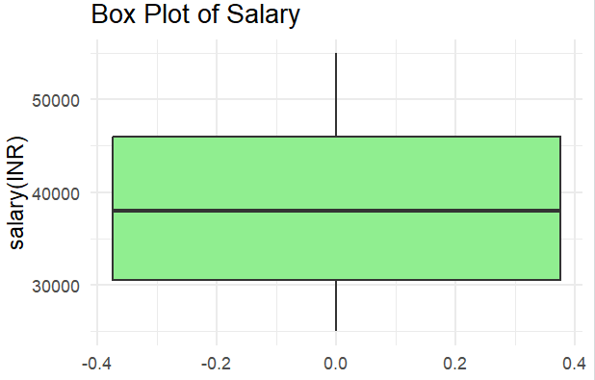

3.Scatter Plot(Age vs Salary)
ggplot(data, aes(x=Age, y=Salary))+
geom_point(color="blue", size=3)+
labs(
title="Scatter Plot of Age vs Salary",
x="Age(Years)",
y="Salary(INr)"
)+
theme_minimal()

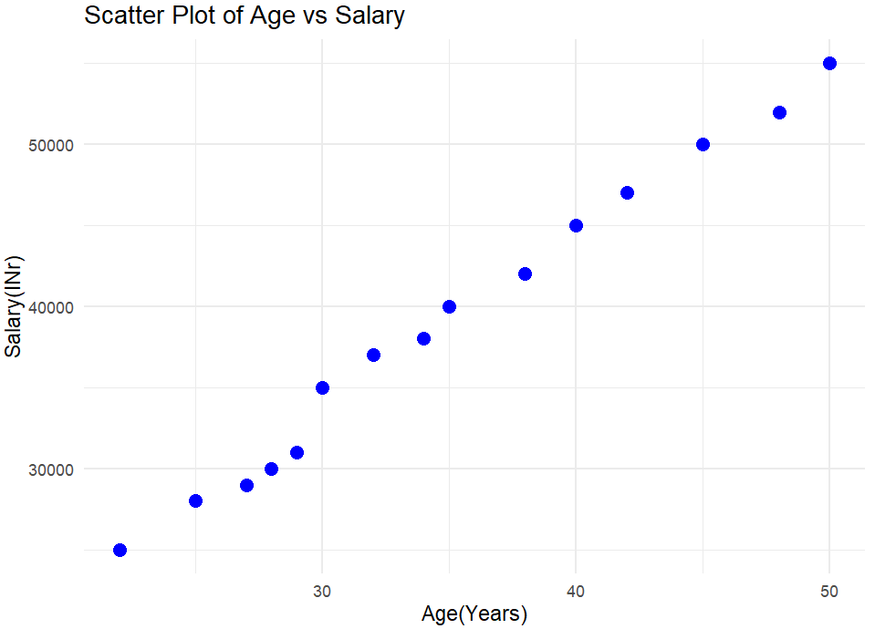

PRACTICAL 10
Aim: Perform linear regression and logistic regression analysis on a dataset. Interpret coefficient and export the result to a CSV file
#Create a sample dataset
data <- data.frame(
Hours_Studied = c(2,4,6,8,10,12,14,16,18,20),
Marks = c(35,40,50,55,65,70,75,85,88,95),
Passed = c(0,0,0,1,1,1,1,1,1,1)
)

#View dataset
data

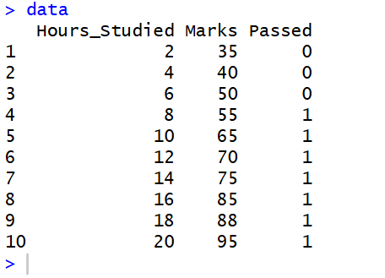

#Linear Regression
linear_model <- lm(Marks ~ Hours_Studied, data = data)
#Model summary
summary(linear_model)
#Convert coefficients to dataframe
linear_results <- as.data.frame(summary(linear_model)$coefficients)

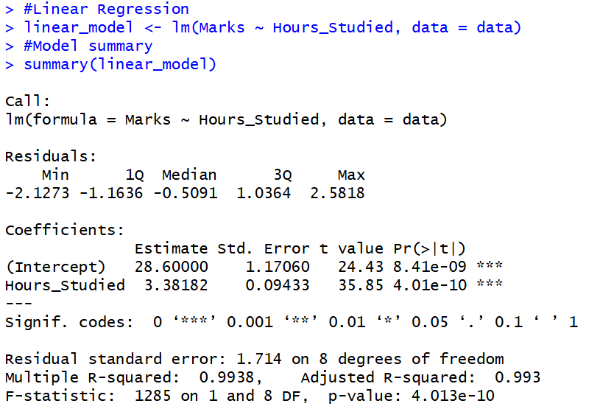
#Export to csv
write.csv(linear_results, "linear_regression_results.csv")
linear_results

logistic_model <- glm(Passed ~ Hours_Studied,data=data,family=binomial)

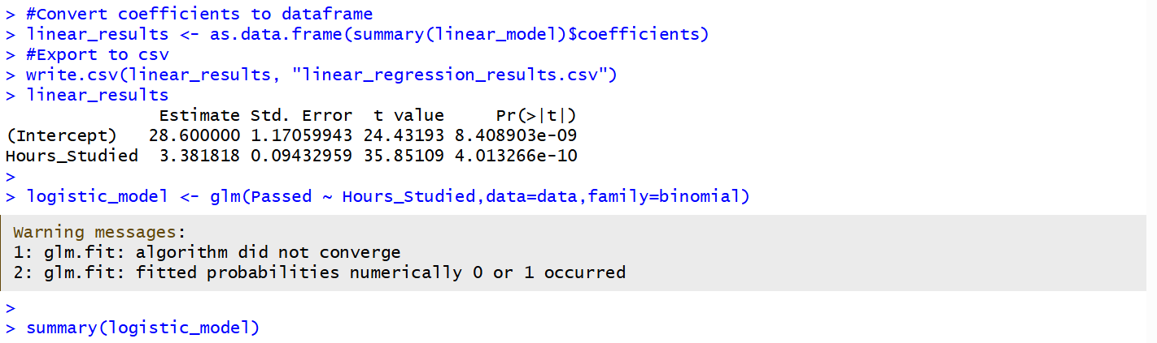

summary(logistic_model)

odds_ratios <- exp(coef(logistic_model))
odds_ratios

logistic_results <- as.data.frame(summary(logistic_model)$coefficients)
write.csv(logistic_results,"logistic_regression_results.csv")
logistic_results

